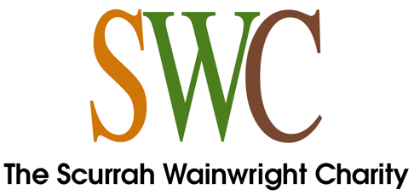
Application Registration Form
The Scurrah Wainwright Charity (SWC) will process your application in line with our policies and procedures detailed on our website. Any personal information relating to your application will be processed in line with our privacy notice, a copy of which can be found here.

I have read and understood information provided on the SWC website | delete as appropriate: YES/NO
Name of organisation:

Name of primary contact:

Position in the organisation:

Address:

Postcode:
Is this address your own or your organisation’s?
Email of primary contact:
Website address:
Legal status of organisation (eg Registered charity, Company limited by guarantee, unincorporated association etc)
Charity registration number (if applicable):
Company Number (if applicable):
Please summarise your proposal in not more than 250 words:

How much funding are you applying for?
What is the total cost of the work to which your proposal relates?
If the total cost is more than requested from SWC, how is the shortfall to be met?
If SWC can only make a grant less than the amount requested, how would the shortfall be met?
When do you hope to start the proposed work?
Over what period of time is your application for?
Who are the trustees of your registered charity, company directors or equivalent?
What was your organisation’s annual turnover for the last financial year?
How did you hear about the Charity?
If your application is successful, to what name should a cheque be payable?

Where an application is unsuccessful with SWC but we think that your application may be successful with the Andrew Wainwright Reform Trust Ltd (company regn. no.: 2608087) (AWRT), we may share your application with AWRT for them to consider further. AWRT will process any personal information in line with their privacy notice, a copy of which can be found here.
If you would prefer us not to share your application with AWRT, please let us know by way of covering email/letter when submitting your application.

Please send your completed Application Registration Form to the Charity’s Administrator, Kerry McQuade, to arrive not later than 14 January (for March meeting), 14 May (for July meeting) or 14 September (for November meeting)
- by email to admin@wainwrighttrusts.org.uk; or
- by post to 19 Wadsworth Lane, Hebden Bridge, West Yorkshire HX7 8DL.

